Varianta 13

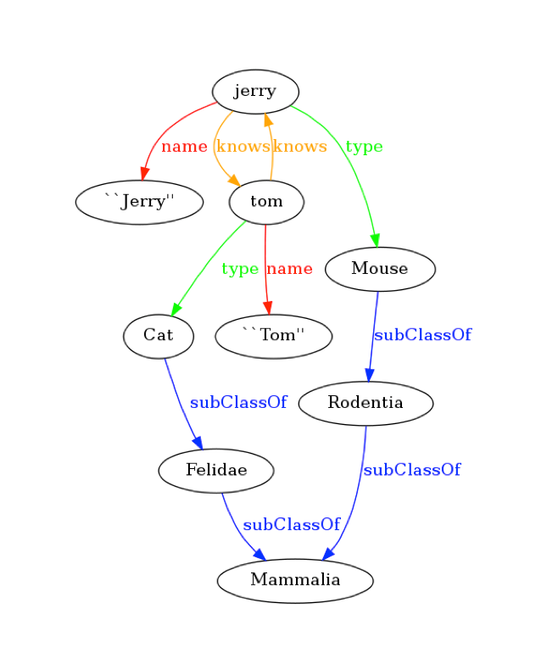

RDF tripluri

jerry name ``Jerry”

jerry knows tom

tom knows jerry

jerry type Mouse

tom name ``Tom”

tom type Cat

Cat subClassOf Felidae

Mouse subClassOf Rodentia

Felidae subClassOf Mammalia

Rodentia subClassOf Mammalia